DESIGN ON PRIORITY AMBULANCE DISPATCH SYSTEM

1. The Problem:
In medical emergencies, response time is critical. Traditional emergency dispatch systems often operate on a "first-come, first-served" basis or rely on human operators who may struggle to quickly assess multiple simultaneous emergencies. A patient suffering a minor cut might call five minutes before someone experiencing cardiac arrest, leading to suboptimal ambulance allocation.
2.The Solution:
An automated, intelligent emergency tracker where:
- Patients or their family members report symptoms, vital signs, and location.
- An AI/ML Engine evaluates the severity score and tags the emergency with a triage colour code:
  - 🔴 Red (Priority 1 - Critical / Life-Threatening): Heart attack, severe trauma, stroke, unconsciousness.
  - 🟡 Yellow (Priority 2 - Urgent): Fractures, moderate asthma attacks, high fever with complications.
  - 🟢 Green (Priority 3 - Non-Urgent): Minor sprains, cuts, mild stomach ache.
- A Priority Dispatch Algorithm in Python routes available ambulances to Red Flag cases first, factoring in both medical urgency and geographic proximity.
3. High-Level System Architecture
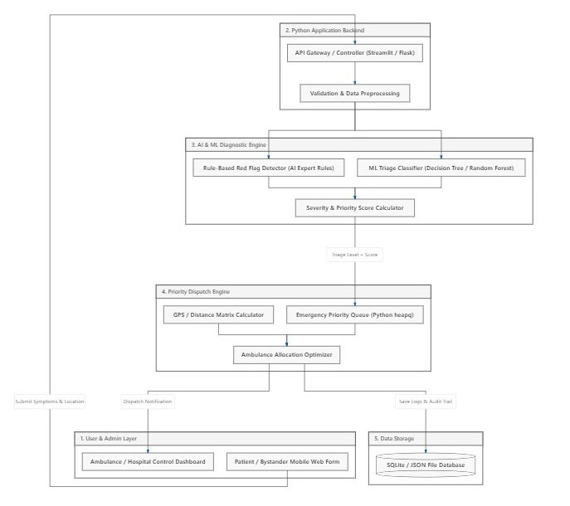

4. Understanding the Roles: Python, AI, and ML
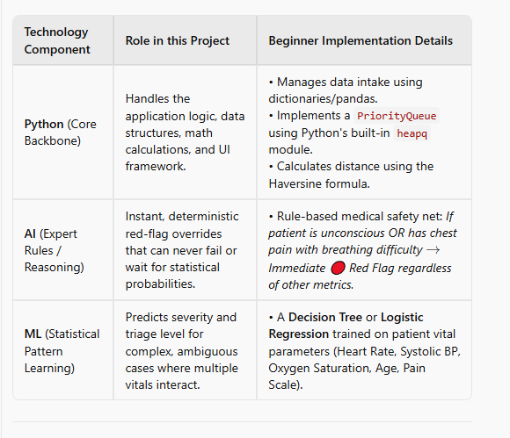
5. Detailed Module Breakdown
Module 1: Patient / Bystander Intake Portal
- Input Parameters:
  - Patient Identity: Name, Age, Gender, Contact number.
  - Location: GPS coordinates or manually selected sector/address.
  - Vital Signs(if known):
    - Heart rate (BPM)
    - Blood Pressure (Systolic / Diastolic)
    - Oxygen Saturation (SpO2​ %)
    - Body Temperature (∘F)
  - Symptoms Checklist: Chest pain, shortness of breath, loss of consciousness, uncontrolled bleeding, severe burn, nausea, etc.
  - Pain Scale: Slider from 1 (mild) to 10 (unbearable).
Module 2: The AI & ML Diagnostic Triage Engine
The triage logic operates in a 2-stage pipeline:
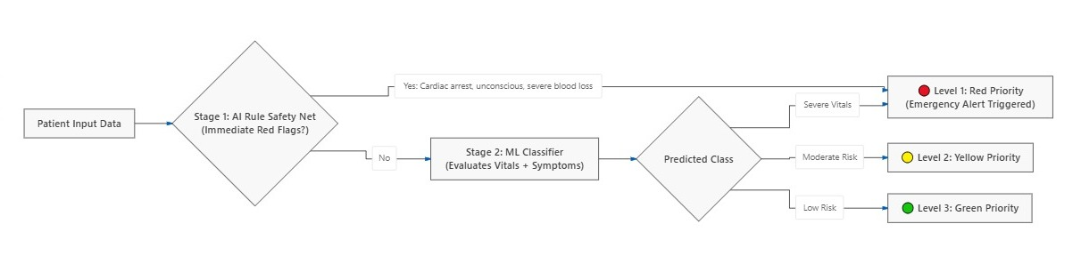
- Stage 1 (AI Hard-Rules): Immediate checks based on clinical guidelines (e.g., Glasgow Coma Scale indicators or Manchester Triage System).
- Stage 2 (ML Severity Scoring):
  - A trained Scikit-Learn model outputs a probability vector: P(Red),P(Yellow),P(Green).
  - Final Priority Score formula: Priority Score=w1​⋅Triage Level+w2​⋅Pain Scale+w3​⋅Waiting Time
Module 3: Priority Dispatch & Routing Engine
Ambulances should not just be assigned to who is closest; they must be assigned to the most critical patient first:
- The system maintains an active Priority Queue sorted by:
  - Priority Category (Red > Yellow > Green).
  - Patient Severity Score (Higher score = higher priority).
  - Waiting time (preventing starvation of Yellow patients).
- Proximity Calculation: Calculates the Haversine distance between each available ambulance and the high-priority incident.
- Dispatch Action: Picks the nearest available vehicle and transitions its status to DISPATCHED.
Module 4: Hospital / Dispatch Control Dashboard
- Live map or grid view showing:
  - Active incoming emergency requests coloured by urgency (🔴, 🟡, 🟢).
  - Locations and availability status of all fleet ambulances (Available, En Route, At Hospital).
  - Audio/visual alert whenever a new 🔴 Red Flag case enters the queue.
6. Data Design & Schema
For a beginner-friendly Python implementation, a relational SQLite database or structured JSON files can be used:
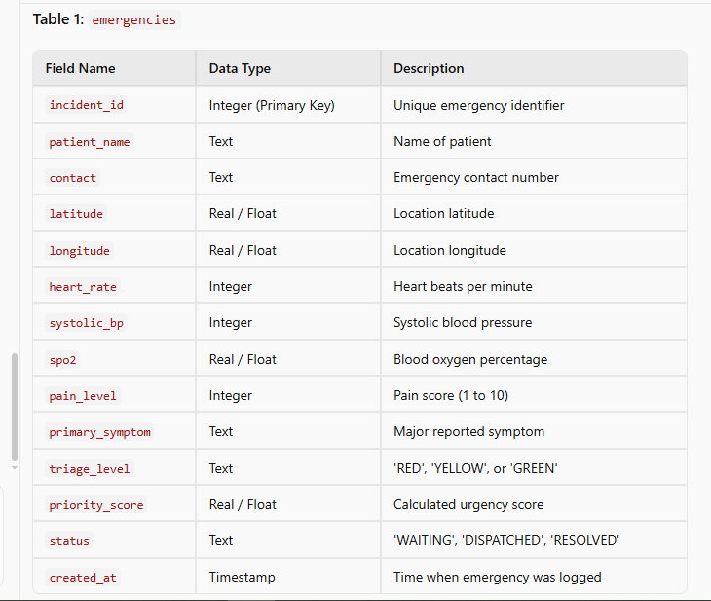
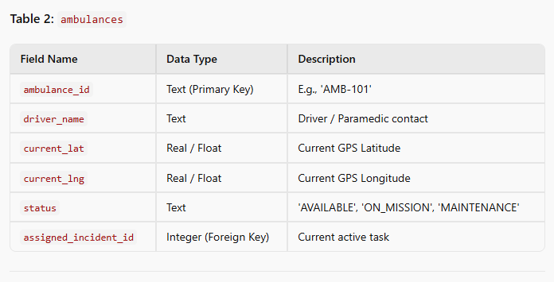
7. Recommended Technology Stack for a First-Year Student
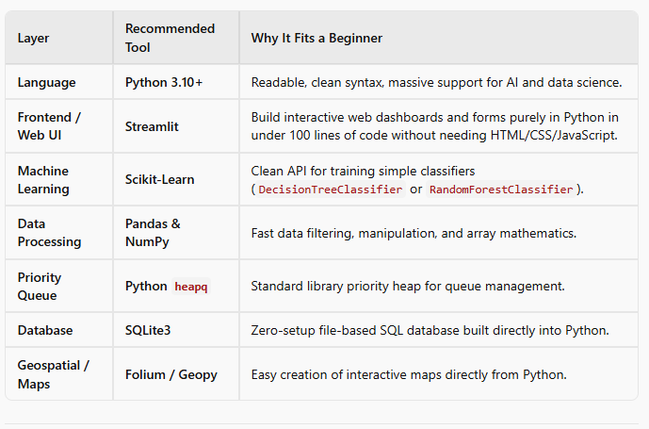
8. Sample Algorithmic Workflow
